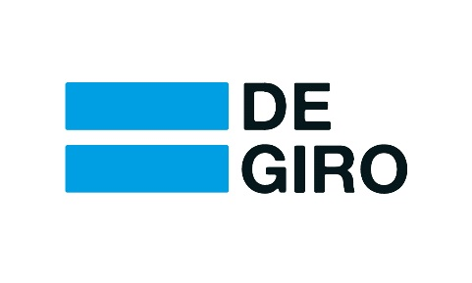

Press Release
Amsterdam, 16 December 2014

DEGIRO Reaffirms Careless Order Routing BinckBank

In response to BinckBank’s press release, DeGiro firmly reasserts its position with regards to both the accuracy and relevance of its published report. The remarkable position espoused in BinckBank’s release makes it clear that their sole objective is to distract from the content of DeGiro’s report.

We extend an invitation to the reader to view our published report. In particular, Appendix 2 carries out a comprehensive examination of the execution quality of our first transaction via BinckBank / TOM. In it, we provide conclusive evidence that TOM’s order routing facility permits flash traders to adversely affect the execution quality of BinckBank’s customer orders.

With regards to BinckBank’s request for rectification, DeGiro’s position is that there is nothing to rectify. The findings in our report have far-reaching implications concerning BinckBank’s careless choice of customer order routing. We believe that BinckBank has chosen to promote great fanfare in order to distract from the core issue.

The discrepancies we have highlighted should serve to encourage a timely and particularly pertinent debate regarding matters of flash trading and the fairness of trading platforms. We find any attempt by BinckBank to distract from this kind of debate regrettable.

For further clarity into the nature of their order routing facility, we have requested post-trade transparency from BinckBank on the other transactions analysed in DeGiro’s report. To date, these requests have unfortunately been denied by BinckBank. Part of this post-trade transparency serves to provide a clearer picture of the market at the moment the Smart Order Router came into action.

With regards to the accusations made by BinckBank towards DeGiro, we respond as follows:

The charge against market manipulation would mean that we, as a broker, would not be allowed to test the effect of adjusting the order routing for our customers, yet this is precisely one of the primary responsibilities of being a broker.

The accusation regarding “comparative advertising” is also unfounded. DeGiro has only made public an objective and comprehensive research report. On the other hand, BinckBank itself advocates the use of its (faulty) order routing facility as one of ten reasons to become a Binck client.

Nowhere in their press release, nor in any other communication, has BinckBank refuted the fact that the execution quality of the test orders sent by DeGiro were disadvantaged by flash trades. Consequently, this implies that BinckBank must also find this fact indisputable.

Besides requesting post-trade transparency on the other transactions, DeGiro also challenges BinckBank to answer the following simple question:

“In 11 out of the 12 test orders which were analysed in DeGiro’s report, were customer orders adversely affected by HFT traders who traded immediately ahead of them? Yes or No?”
In clarification, with the exception of the two previously mentioned substantive points, every response by BinckBank so far has only regrettably served to distract from the central issue and its profound implications.

Results of the DeGiro test: https://www.degiro.nl/data/pdf/DEGIRO_Research_TOM.pdf

About DeGiro

DeGiro is an online broker which provides access to the market via its online platform. DeGiro currently operates in 11 European countries. DeGiro offers private investors across Europe professional trading fees of up to 80% lower than the competition. Through the DeGiro platform, investors in Europe connect to the world’s financial markets. DeGiro is on track to be the largest European broker by trading volume in the next few years. DeGiro operates under the supervision of the Dutch Central Bank (DNB) and operates under the full regulatory scope of the Dutch Financial Markets Authority (AFM). For more information, please visit www.degiro.nl.

--------------------

